CHAPTER THREE
DESIGN METHODOLOGY
3.0 DESIGN
This chapter contains the design analysis, calculations, component selection and design specification.
The design was divided into the following units for simplicity and efficiency. Below are the following units of the project:
- The Power supply unit
- The Level Sensor unit
- The Controller Unit
- The Display unit
- The Alarm Unit
- The GSM/GPRS Unit
- The FCE/PUMP control unit

3.1. DESIGN SPECIFICATION
This System has the following Design Specifications:
Input Voltage: 220/230V AC @ 50Hz.
Level Sensor Type: Hydrostatic pressure Sensor
Level Measurement Range: 0CM to 100CM
Display: Supports Visual Presentation of the Level 16x2 liquid crystal display (LCD).
Pump Type: ½ HP (500watts), Centrifugal Water Pump.
Process Type: WATER.
Controller Type: PIC16F877A Microcontroller from Microchip Corporation.

3.2 DESIGN DETAILS
3.2.1 POWER SUPPLY UNIT
This unit converts the 220V AC to 5V DC required by the circuit. It was implemented with the following components:
• 220V/12V step down transformer
• Bridge Diode
• Capacitor
• Voltage regulator
Below is the circuit diagram of the power supply unit:

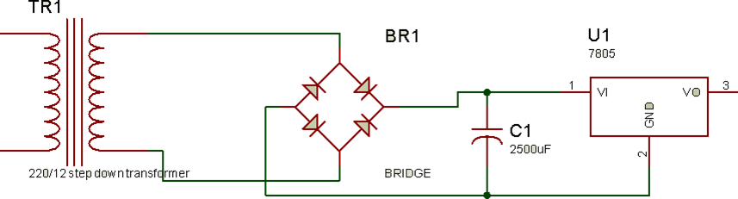
FIG 3.1 Power Supply Unit

Voltage Regulator:
As we require a 5V we need LM7805 Voltage Regulator IC.
7805 IC Rating:
• Input voltage range 7V- 35V
• Current rating Ic = 1A
• Output voltage range VMax=5.2v ,VMin=4.8v
Transformer:
Selecting a suitable transformer is of great importance. The current rating and the secondary voltage of the transformer is a crucial factor.
• The current rating of the transformer depends upon the current required for the load to be driven.
• The input voltage to the 7805 IC should be at least 2V greater than the required 2V output, therefore it requires an input voltage at least close to 7V.
• So we chose a 12V transformer with current rating 500mA (Since 12*√2 = 16.97V).
Rectifying circuit:
The best is using a full wave rectifier
• Its advantage is DC saturation is less as in both cycle diodes conduct.
• Higher Transformer Utilization Factor (TUF).
• 1N4007 diodes are used as it is capable of withstanding a higher reverse voltage of 1000v whereas 1N4001 is 50V
• Center Tap Full Wave Rectifier
The bridge rectifier converts the ac voltage input to dc voltage at its output.
The choice of the bridge rectifier depends on:
i. Peak inverse voltage.
ii. The forward current rating
The diode forward current rating is the maximum that the diode can conduct before failing. The diode should be selected in such a way that the current passing through it should be less than the forward current rating. The peak inverse output is the reverse voltage that the diode has to block when not conducting.
Peak inverse voltage =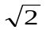 x Vrms
where Vrms = transformer output = 12Vac
 peak inverse voltage = x 12 = 16.97v
 The diodes used has forward current ≥ 500mA and Piv ≥ 16.97V
The diodes IN4007 was used.
Selection Of the Filter Capacitor (C1)
The filter capacitor smoothens the dc voltage from the bridge rectifier.
The choice depends on
i. The capacitor breakdown voltage
ii. The ripple percentage required
Capacitor breakdown voltage (Vc) is gotten by taking KVL from the bridge rectifier output to capacitor terminal. Using Fig. 3.1
Vpeak – Vd – Vc = O
Where Vpeak = bridge rectifier output
Vd = drop across bridge rectifier diodes
Vc = capacitor terminal voltage
16.97v – 1.4v – Vc = 0 ------------- (3.1)
For full wave rectification, on each half section, 0.7 is drop across each of the two conducting diodes. Which gives 1.4v (2 x 0.7v)
 equation (3.1) becomes
15.57 – Vc = 0
where Vc = 15.57V
In practices, the rule is to use a capacitor with breakdown voltage double of the terminal voltage
 V1c = 2 x Vc
V1c = 2 x 15.57
= 31.14V
A standard value of 35V was used.
Capacitor Capacitance

C= I load/ 2fVΔ for full wave
Where VΔ is the difference between the maximum peak voltage and the minimum peak voltage.
Maximum peak = 15.57v
Minimum peak = 15.57 - % ripple
% ripple = 15.57 – minimum peak
taking minimum peak = 13.57v
% ripple = (15.57 – 13.57)v = 2v
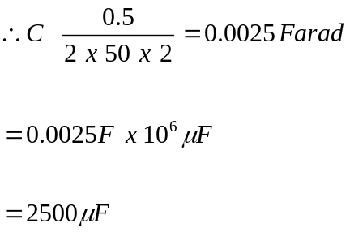
A standard value of 2500uf capacitor was used.
3.2.2 THE LEVEL SENSOR UNIT
This unit measures the Process (WATER) level in the Reservoir. It senses the pressure and outputs a signal that is proportional to the pressure been measured.

Requirements of the Level Sensor
- It should be able to measure the process level within a reasonable range.
- It should be easy to use and requires less biasing components
- The power requirements should be reasonable
- it should be cost effective and readily available
- It’s output signal should be easily interfaced with a controller.

Selection of the Level Sensor
The 2 wire pressure transmitter from Rosemount Corporation was selected. Below are some of its features:
- power range from 12V to 30V DC
- Pressure range is 1 to 300PSI
- 4mA to 20mA output signal on two wire
- biased with a 250 ohms resistor to convert the voltage to 1 – 5V
- Portable in size for easy installation.
The pressure transmitter is strategically fitted at the bottom of the fabricated rectangular reservoir that contains the process to be controlled for this design. The output terminals of the pressure transmitter is connected to one of the Analog to digital converter input pin of the microcontroller. Below is the interface calculation between the pressure transmitter unit and the microcontroller.
The voltage signal from the pressure transmitter is directly proportional to the pressure measured.
For example:
Voltage signal from transmitter = 2.5V
Transmitter Range = 300PSI
Therefore, with direct proportionality, the Pressure measured is: 150PSI.
Converting the Pressure to Level using Hydrostatic Method;
Recall; P = phg. Where P = Pressure; p = Density; h = Level/Height; g = acceleration due to gravity.
h = P/pg;
P = 150PSI; p = 1000g/m⁻²; g = 9.81ms⁻²
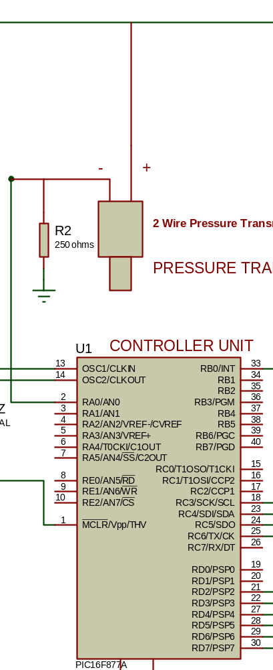
Figure 3.2: The pressure transmitter and the microcontroller interface
3.2.3 THE DISPLAY UNIT
This Unit gives a Visual Presentation of the Water Level (in cm) inside the Reservoir.
Requirements for the Display Unit
- Should be large enough to give a clear visual presentation of the Water level.
- Be Large Enough to Represent the Level of the Process in the Reservoir.
- Should be easy to Use or Programmed.
- Should have an easy connection interface i.e. less biasing components.
- Should be available and Cost effective.
Selection Of the Display Unit
16x2 (16 characters per Row, 2 Rows) liquid crystal display was selected. Below are the choice of the selection:
- It gives a clear visual presentation of data.
- It can to represent the Level of the Process in the Reservoir.
- It has an easy connection interface.
- It is cheap.
- It is available.
The display unit gets its DATA from the Controller Unit. It is connected to The PORTD PINS of the PIC16F877A Microcontroller. Below is the circuit interface of the Display unit
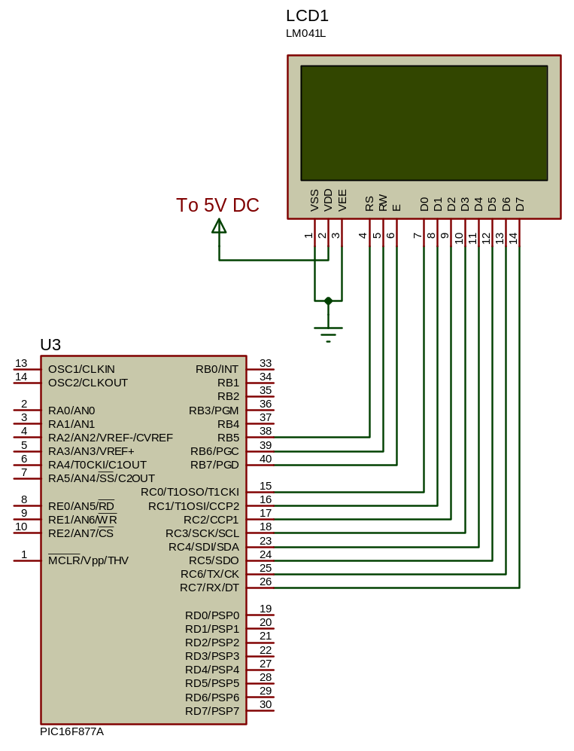
FIG 3.3 Display Unit Interface with the Controller unit
3.2.5 THE PUMP AND PUMP/FCE CONTROL UNIT
The pump control element was implemented with a 220V AC 1/2hp Water pump. The FCE Control unit is switching circuits that assist the Controller unit to switch the Pump ON and OFF. Below are the requirements of the unit:
Requirement of the Switching circuit
- It should not be a complex switch circuit.
- It should be able to Power the Pump.
- It should be easily controlled by the controller unit i.e. easy connection interface.
- The components involved should be available and cost effective.
Selection of the Switching Circuit
The transistor switching circuit was selected. It was implemented with the Following Components:
- 12V 30A Relay
- BC547 NPN Transistor
- Biasing Resistor
The transistor switching circuit was selected because it meant the above requirements. This Unit is directly controlled by the Microcontroller through PIN 15. Below is the Circuit diagram of the entire Unit.
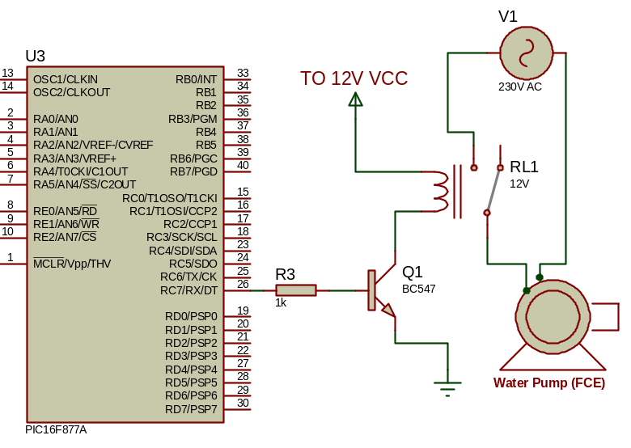
FIG 3.4 FCE Control Unit

Selection of the Switching Transistor
The choice of the switching transistor is based on:
1. The supply voltage
2. The maximum collector current
To determine the collector current, Collector current = relay coil current.
Relay coil current = Relay coil voltage
Relay coil resistance
= 12v
275 Ω = 0.04A = 40mA
The general purpose transistor BC547 was used.
The BC 547 has the following specifications:
Gain (ß) = 120
V_{BE} = 0.7V
I_{C}(max) = 60mA
Selection of the Relay
The choice of the relay is based on:
1. Supply voltage
2 Relay contact current
3. The Watts requirement of the Pumps
Pump used has the following specification:
Input voltage: 220v AC.
Watts: 500 watts (1/2 Hp).
Using a Relay of 12V 30A DC (JQX12)
Supply voltage in the circuit = 12V.
Power Of the relay: P=IV = 30A x 220V = 6600watts = 6.6KW
Therefore the Relay power is greater than the Pump Power requirements i.e. 6.6KW > 500Watts
3.2.6 THE CONTROLLER UNIT
This Unit is the Heart of the Entire System. It performs the entire logic of the system. Below is the requirements of the controller unit.
Requirements of the Controller
- Should be able to interface the display unit.
- Should have ADC Module required to interface the pressure transmitter.
- Should have UART Module required to interface the GSM/GPRS Module
- Should be stable and efficient.
- Should have enough Input/output Pins to accommodate the entire system.
- Should be easily programmed.
- It should available and cost effective.
Selection of the Controller
The PIC16F877A Microcontroller From Microchip Corporation was selected. Below are the reasons of the selection.
- It is a 40pin Microcontroller, it has enough input/output pins.
- A pin in the microcontroller can supply 5V 20mA.
- It has internal ADC Module Required to interface the Pressure transmitter
- It Has UART Serial communication Module Required by the GSM/GPRS Module.
- It has an easy programming interface.
- It is stable, cost effective and available.
The PIC16F877A Microcontroller was biased with a 16Mhz Crystal and two (2) 15pf Capacitors.
To determine the time the microcontroller executes one instruction
One machine cycle is the time taken to execute an instruction
Machine cycle = 4 pulses of crystal oscillator.
Hence, time taken = Oscillator Frequency
4
For one machine cycle
= 16MHZ = 4MHZ
4
1/F= 1/4MHZ = 1s
The controller executes one instruction in 1 micro seconds.

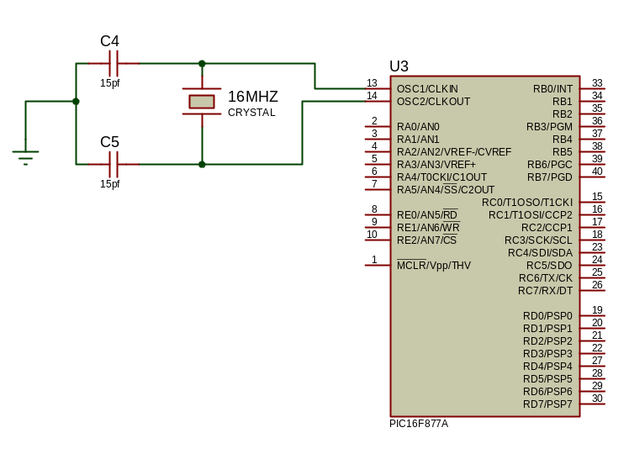
FIG 3.5: The Controller Unit
3.2.7 THE ALARM UNIT
This Unit Gives Audible Sound For when the process level reaches the SET Point. Below is the requirement of the ALARM unit.
Requirements of the ALARM Unit
- Should be able to give a good audible alert.
- Should have feasible connection interface.
- Reasonable power requirements i.e. input voltage and current demand.
- Should be cost effective and readily available.
Selection of the ALARM
The unit was implemented with a DC Buzzer Alarm. Below is the choice of the selection of the buzzer alarm:
- It has a wide operating voltage i.e. 5-24V
- It gives a clear and audible sound.
- It is easily biased with a resistor.
- It is cheap and very available.
The Unit is Directly Controlled by the Controller Unit. It is connected to Pin 19 of the PIC16F877A Microcontroller. It was biased a 1K Resistor. Below is the circuit diagram of the Buzzer Unit:
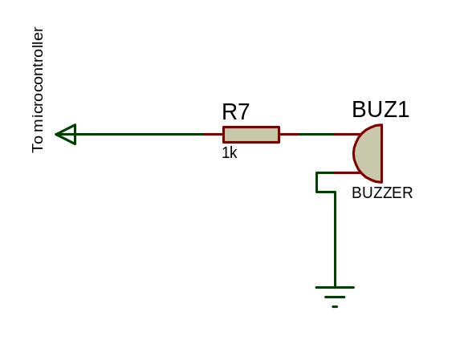
FIG 3.6 The Alarm-Buzzer Unit Circuit
Buzzer Operating Current
The buzzer operates with a voltage of 5-25V;
Current: 2mA to 10mA;
A pin of the microcontroller can supply 5V (as specified in Pic16f877a microcontroller datasheet)
Supply 5mA at 5V to the Buzzer:
From Ohms law: V=IR;
R=V/I
V=5V; I=5mA
R = 5/(5x10⁻³) = 1000;
Therefore R=1K ohms.
3.2.8 SELECTION OF THE GSM/GPRS MODULE UNIT
This unit Enables the microcontroller to send and receive DATA over the IOT Network.
After research, this unit was implemented with SIM800L Module from SIMCOMM Group. Below are some of its features:
- It use RS232 serial communication protocol i.e. TX, RX and common terminal.
- It uses GSM/GPRS AT command sets. Easy protocol for the microcontroller
- It operates with 5V DC at 100m A
- It requires no biasing components and available and cost effective
The SIM800L is a cheap and portable GSM breakout board with all the capabilities of the larger SIM900 shields. Here are the features of the SIM800L breakout board:

- 2G quad-band @ 850/900/1800/1900 MHz
- Receive and make calls using the speaker and microphone outputs
- Receive and send SMS
- Connect to the Internet via GPRS
- Listen to FM radio broadcasts
- Accepts AT Commands
The Unit directly interfaced with the microcontroller. Below are the AT Command sets used between the microcontroller and the SIM800L Module to transmit over the IOT.
AT + RST
AT + CIPMODE=1
AT + CIPSTART=”TCP”,”mathworks.net”,80
AT + CIPSEND
GET /iot/data.php?level&time&date HTTP/1.1
Host: mathworks.net
See appendix A for complete source code. Below is the circuit interface between the microntroller and the GSM/GPRS Module unit.
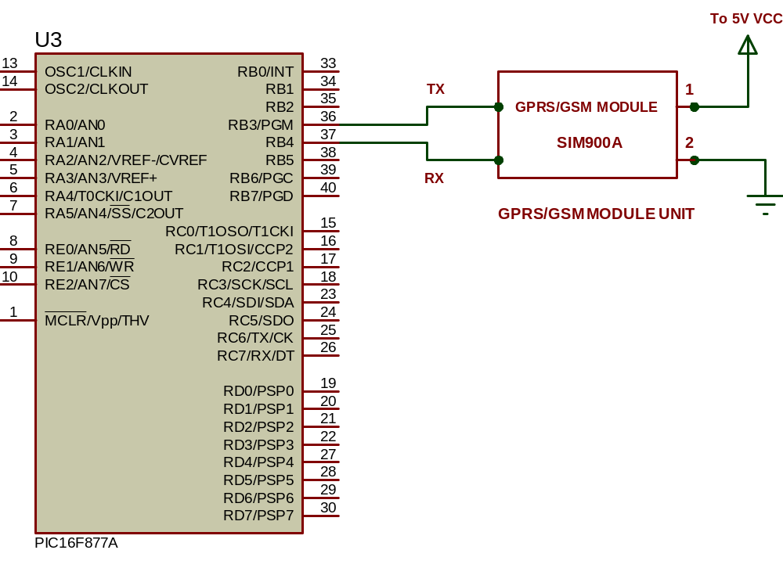

Communication Data format between the controller and the IOT Application
The Controller transmit a 24bit (3 byte) DATA packet to the IOT Application at every 30 seconds. Each byte in the packet represent the Level value of a process. The IOT Application receives the 3 byte packet data, parse it and displays it on the Process image in the Application.
The IOT Application transmit a 1 byte CONTROL Packet to the microcontroller, where the byte represent the control state of the FCE Of the process. The byte can either be 00H or FFH i.e. OFF FCE or ON FCE respectively.
The communication baud rate between the controller and the IOT Application through the GPRS/GSM module is 9600bps.

3.2.7 IOT APPLLICATION
This is a graphical user interface unit of the system. It was designed with Microsoft visual studio 10 using C# Programming language. The Design carries one reservoir image, the reservoir image represent the Level of the process.
The IOT Application also has TWO TEXTBOX AND BUTTON under the reservoir image, it is used to input the LEVEL SET POINTS of the Process. See the Pictorial View of the IOT Application and source code at APPENDIX.

3.3 SOFTWARE DESIGN
The software design is divided into three stages. These are algorithm generation, flow chat representation and coding.
3.3.1 ALGORITHM GENERATION
An algorithm is a statement of the procedure adopted in solving a problem. The sequence of the system operation is stated below:
- Initialize the system on start.
- Initialize the display unit.
- Get Signal from pressure transmitter and convert to Level.
- Update the Display Unit depending on the value read.
- Update the Pump control unit.
- Transmit level value to IOT application using the GSM/GPRS Module.
- Wait for control Packet from IOT Application
- Update Pump Control Unit based on Control packet Received.
- End process.
3.3.2 CODING
The coding is done in C language. The code contains the instruction of program to direct the affairs of the entire design. There are six subroutines in the complete code. Each subroutine performs specific function as group of instructions. The subroutine and functions are stated as follows.
1. Initialization: This subroutine initializes the microcontroller including preloading the counters and reference values for the system. .
2. Read Signal: This subroutine makes the controller to get the voltage signal from the ADC.
3. Conversion: This subroutine converts the value read from ADC to the equivalent level.
4. Update Display: The subroutine enable the controller to display value on the LCD display.
5. Update Control: This subroutine enable the microcontroller to control the switching circuit
6. IOT: This subroutine enables the controller to transmit and receive data over the IOT Network to the Application

3.3.3 FLOW CHART

START
INITIALIZATION

PERFORM ADC ON THE PRESSURE TRANSMITTER OUTPUT PIN

CONVERT IT INTO LEVEL VALUE

SEND TO FIELD DISPLAY UNIT
SEND TO IOT APPLLICATION
UPDATE PUMP FCE UNIT BASED ON CONTROL PACKET
END

WAIT FOR CONTROL PACKET FROM IOT APP.

3.4.0 CIRCUIT DIAGRAM
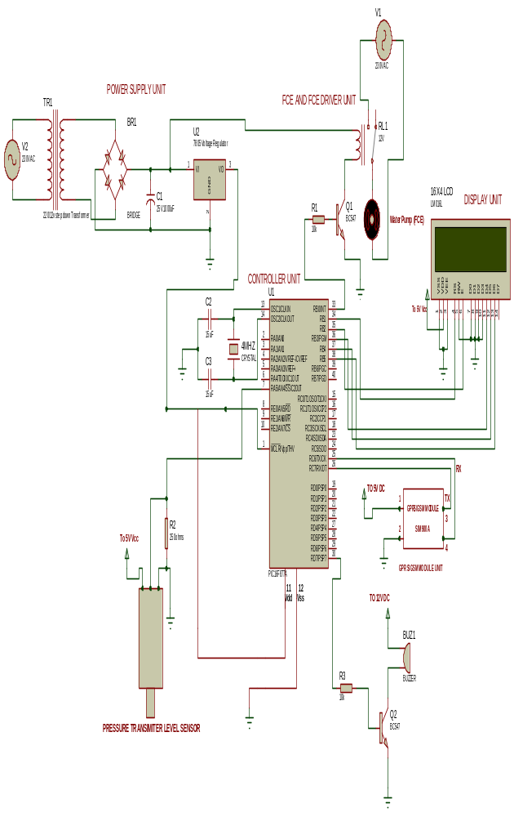

3.4 PRINCIPLE OF OPERATION
On power up, the power supply unit provides 5V DC for the microcontroller, LCD, SIM800L and 12VDC for the pressure transmitter module. The microcontroller then initializes its internal registers and also the LCD Display.
It then read the Voltage signal from the ADC pin connected to the pressure transmitter, converts the signal to the equivalent level, display the value on the LCD and transmits the value to the IOT application through the GSM/GPRS Module. When the application receives the data packet, it updates it on the Reservoir GUI image, it then compare the received value with the SET Points, and sends a control packet to the Microcontroller based on the output of the comparison. The microcontroller upon receiving the control packet, updates the FCE Control unit based on the received control packet. The entire process is repeated again.

CHAPTER FOUR

4.0 CONSTRUCTION
This chapter contains construction details. The construction consists of three main steps namely:
- The construction of the hardware
- Software development
- Installation

4.1 CONSTRUCTION OF THE HARDWARE UNIT
The hardware unit consists of the electric circuit. In the construction of the electronic circuit, the following tools or materials were used
- Digital Multimeter
- Soldering Iron
- Head Sucker
- Side Cutter
- Sand Paper
- Circuit Probes
- Soldering Lead
4.2 CONSTRUCTION PROCEDURES
We have the following procedure adopted in the construction of the electronic unit.
i. Pre-connection and Testing: the components were first connected on a project board to test their functionality and to effect any change if need be.
ii. Component layout and placement: The actual connection was done on a new board. First, the new board connection surface was cleaned by robbing lightly with the sand paper, there after the positions of the components were marked out on its surface. The essence of this is to maximize the Vero board space.
iii. Inter Connection: The various components were interconnected according to the wiring diagram. The connections were made using components, lead and connecting wires.
iv. Joining Operation: The resulting joints were soldered using hot soldering iron and soldering lead.
v. Clearing Operation: Excess soldering lead and soldering lead between Vero board tracks were removed using the lead sucker.
4.3 CONSTRUCTION DETAILS
The construction of this project is divided into the following groups:
- Construction of the Circuit
- Construction of the Casen
4.3.1 CONSTRUCTION OF THE CIRCUIT
The circuit was constructed with the following components: pic16f877a microcontroller,
16x2LCD display (3), 220v/12v step down transformer, 7805 voltage regulator,
Resistors, Led, 12v 30A Dc relay, connecting belt, Off and On switch, etc. These components was properly soldered on a PCB according to the above circuit diagram. Care was taken to avoid mistakes and errors.
After the construction, the whole circuit was fitted with bolt and nut inside a white rectangular plastic Casing (15cmx10cmx10cm). Below is a pictorial view of the project construction:

4.3.2 CONSTRUCTION OF THE CASING
The Casing is made up of ½ hp water pump, two cylinders containers, rectangular box, water pipes, valve etc. For the two Cylinders containers, one serves as the Sump while the other is the Reservoir. The suction line of the pump was connected to the bottom of the Sump cylinder, while the discharge line is connected to the top of the reservoir cylinder.

4.4 SOFTWARE DEVELOPMENT
Since it is an embedded system, software part must be added to give a complete system. The software development passed through the following stages.
i. Coding
ii. Crating text files.
- Compiling
- Simulating
- Debugging
- Burning

i. Coding: the program codes to determine the operation of the system was generated. These were written down on paper using the instruction set corresponding to micro-controller use. All signals were adhered to, to prevent obvious errors.
ii. Creating Text File: The text files was created by using note pad editor and the codes on paper through the note pad work space were typed into the computer system and saved with an “ASM” extension..
iii. Compiling: This is done to convert the text file to HEX file. The V edsim 51 IDE was used. The program code on the editor was assembled. HEX file was generated along side a list file and error report file. The error report file contains errors, especially syntax errors, The list -file is an editable file that shows errors in the code which prevents successful compilation.
iv. Simulating: The program HEX file, referred to as the object code was then simulated. All commands are within the development environment. The movement of data and process within the microcontroller can be easily seen. Also, output and input devices are available to mimic the actual, physical construction.
v. Debugging: illegal operations were corrected by way of debugging the source codes until the required operations were obtained. The steps taken in debugging are as follows:
a. The list file was opened so as to locate any errors that may be present in the program.
b. Each program line with errors is displayed in the list file.
c. Corrections were made in the main programs with reference to the lines with errors in the list file.
d. The program was recompiled again after necessary corrections have been made.
e. In absence of any other error, the list file indicated it.
vi. Burning: This is the process of loading the HEX file into the microcontroller. The writing of the hex file into the chip was done using a programmer. The hex file basically consists of assembly code level. The programmer converts this to machine code understood by the microcontroller.
The programmer (Wellon 2008) was connected to the PC’s USB port.
The software program controlling the programmer was launched with command, the chip to be programmed was selected, erased, checked for blankness before writing the loaded hex file into the chip. After writing was done, the system notified the programmer and the chip was removed from USB programmer device.
4.5 TESTING AND RESULT
The tests and results are given in the table below.

Table 4.1: Test and Result
Test | Aim | Equipment used | Result | Conclusion
Short circuit test | To detect short circuit on the electronic circuit | DMM | All the test points R>1Ω | No short circuit present in the circuit connection
Open circuit test | To detect open circuit on the electronic circuit | DMM | All the tested points read R>1Ω | No open circuit was present in the circuit connection
Operation test | To ascertain the functionality of the system | The system was powered and observed | Operated as required | System in good condition

4.6 COST ANALYSIS
Project Cost Estimate
S/n | Description of item | Qty | Unit Price (N) | Total (N)
1 | 220/24V Transformer | 1 | 1500 | 1500
2 | Rectifier diodes IN5403 | 4 | 150 | 1000
3 | 10k resistor | 10 | 20 | 200
4 | 25V,1000 micro Farad capacitor | 2 | 100 | 200
5 | 5KΩ variable Resistor | 1 | 200 | 200
6 | PIC16f877A | 1 | 4000 | 4000
7 | 2 wire Pressure Transmitter sensor | 1 | 33000 | 33000
8 | LM7805 | 2 | 100 | 200
9 | SIM800L GSM Module | 1 | 15000 | 15000
10 | LED | 10 | 30 | 300
11 | Plastic Casing | 1 | 2500 | 2500
12 | OFF/ON switch | 1 | 150 | 150
13 | 16x4 LCD display | 1 | 3500 | 3500
14 | PUMP | 1 | 12000 | 12000
15 | 1k Resistors | 14 | 10 | 140
16 | Connecting belt Wires | 3 | 150 | 450
17 | Connecting wires (CAT 6) | 3 | 150 | 450
18 | 40 pin IC socket | 1 | 30 | 30
19 | I6 pin IC socket | 3 | 30 | 90
21 | Cylinders | 2 | 2000 | 4000
22 | Connecting pipes | 1 | 1200 | 1200
23 | Pipe fittings |  | 4500 | 4500
24 | Soldering Led | 1 | 2000 | 2000
25 | 12v 30A relay | 1 | 700 | 700
26 | BC547 transistors | 2 | 150 | 300
27 | 13A socket and Plug | 2 | 350 | 700
28 | Rectangular Box CASEN |  |  | 4500
29 | 2.5mm copper wire | 2 | 400 | 800
30 | Vero Board | 2 | 350 | 700
31 | Typing and photocopies |  |  | 8,000
32 | Binding |  |  | 2,800
 | Total

CHAPTER FIVE
5.0 CONCLUSION AND RECOMMENDATION
The conclusion and recommendation are discussed in this chapter. Furthermore, a highlight of the experience gained, problem encountered and recommendations are also discussed.
5.1 CONCLUSION
A successful attempt has been made to design and construct of a level control using hydrostatic pressure rig interfaced with IOT using locally available material. The system is capable of enhancing level measurement and control. The completed work had been tested and worked satisfactory.
A research approach was adopted in the implementation of this system, from whence a workable circuit was designed. The design was done using embedded system technology. This is to reduce component count, keep the system simple and cost effective.
In the realization, of the unit, certain challenges were faced, such as component procurement, hardware and software implementation. These were overcome with appropriate consultations and research. The use of microcontroller programming interactive development environment (IDE), the software problems were overcome, and with the use of microcontroller simulators the hardware problems were overcome, Furthermore, the project work has enabled me to apply engineering knowledge in solving everyday problem.
5.2 RECOMMENDATION
Future works should include the using of more efficient routing algorithms to extend the network to wide area. A future work also lies on Integration of turbidity sensor, dissolved oxygen sensor and color sensor to the sensors used in this work.
REFERENCES

- T. Lambrou, C. Anastasiou, C. Panayiotou, and M. Polycarpou "A low-cost sensor network for real- time monitoring and contamination detection in drinking water distribution systems", IEEE Sen- sors Journal, vol. 14 Issue 8, pp. 2765-2772, 2014.
- Dong He, Li-Xin Zhang "The water quality monitoring system based on WSN", IEEE International Conference on Consumer Electronics, Communication and Networks, pp. 3661-3664, 2012.
- Niel Andre Clote,Reza Malekian,Lakshmi Nair "Design of smart sensors for real time water quality monitoring," IEEE Journal, vol. 4 Issue 9, pp. 3975- 3990, 2016.
- Muhammad Azwan Nasirudin,Ummi Nusulhaiza zabah,O.sidek "Fresh water real time monitor- ing system based on wireless sensor network and GSM", IEEE Conference on open systems, pp. 354- 357, 2011.
- AN Ning, AN Yu "A monitoring system for water quality", IEEE International Conference on Electrical and Control Engineering,, pp. 4615- 4617, 2010.
- Tharaja B. L, Tharaja A. K. (2001), A Text Book of Electrical Technology, S. Chand & Company Ltd. New Delhi INDIA 22nd Edition, P. 1730 – 1731
- Boylestad and Nashelsky “Electronics Device and Circuit Theory” (Ninth edition) 2007.
- Bernard Grob “Electronics Circuits and Applications” First Edition 2006.
- 6. www.alldatasheets.com
- Inan Sinclair, John Dunton, “Practical Electronics Handbook Sixth Edition 2007.

